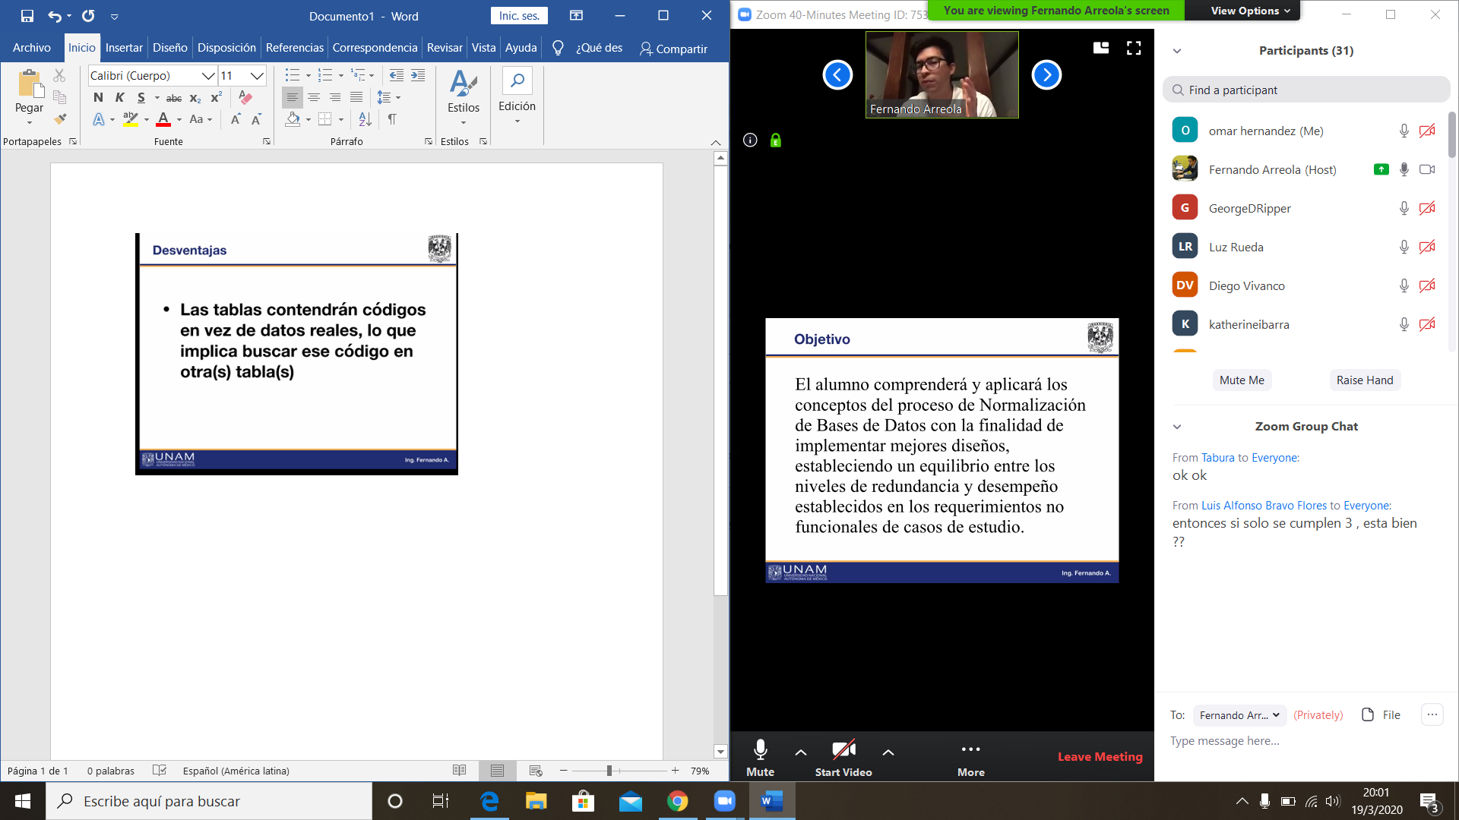

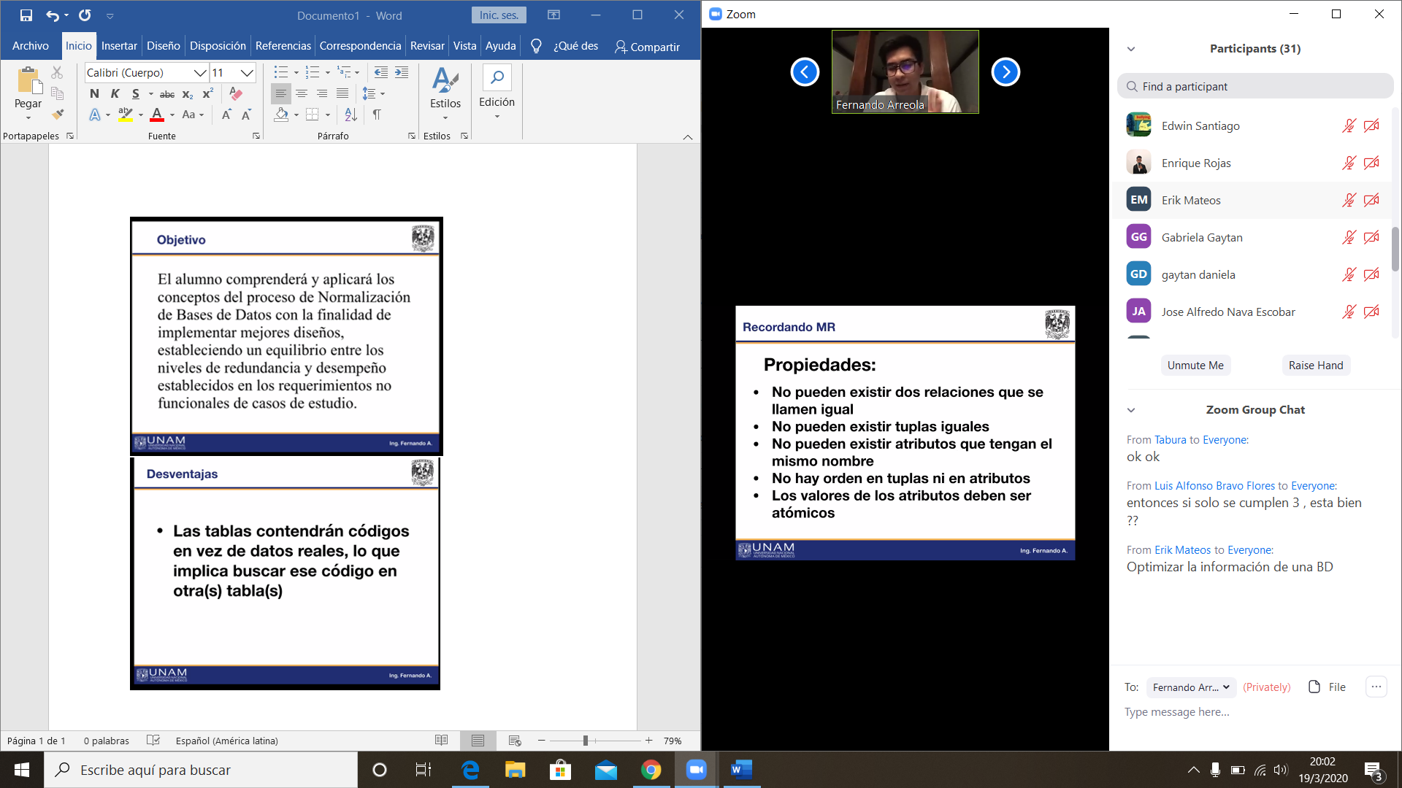

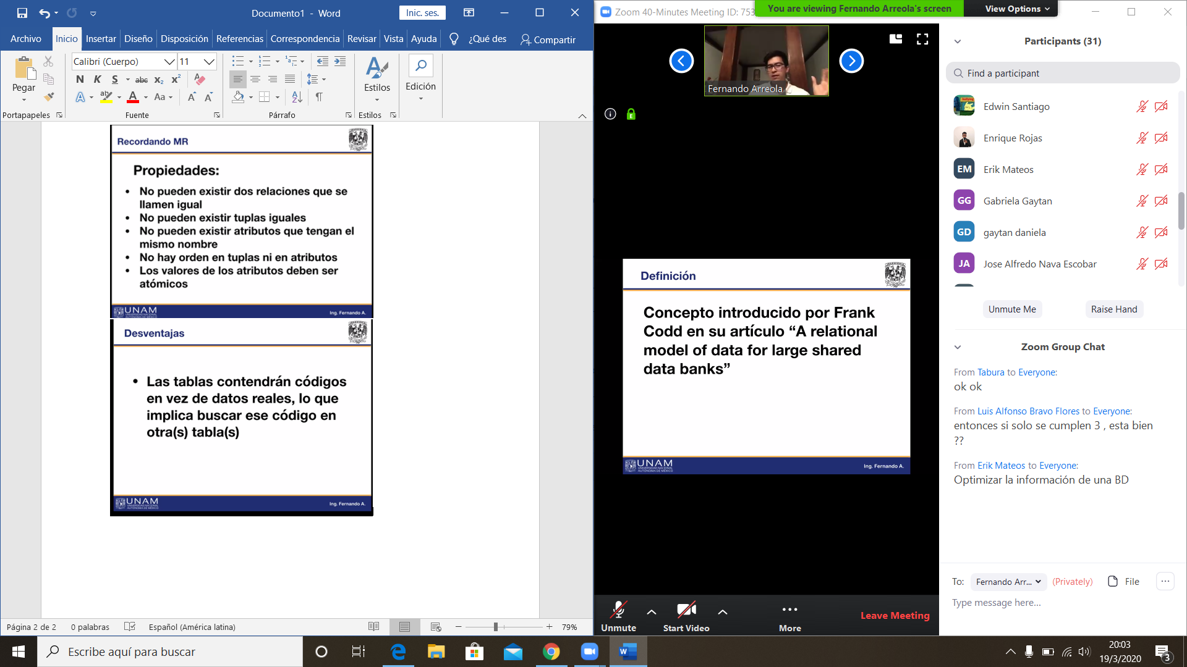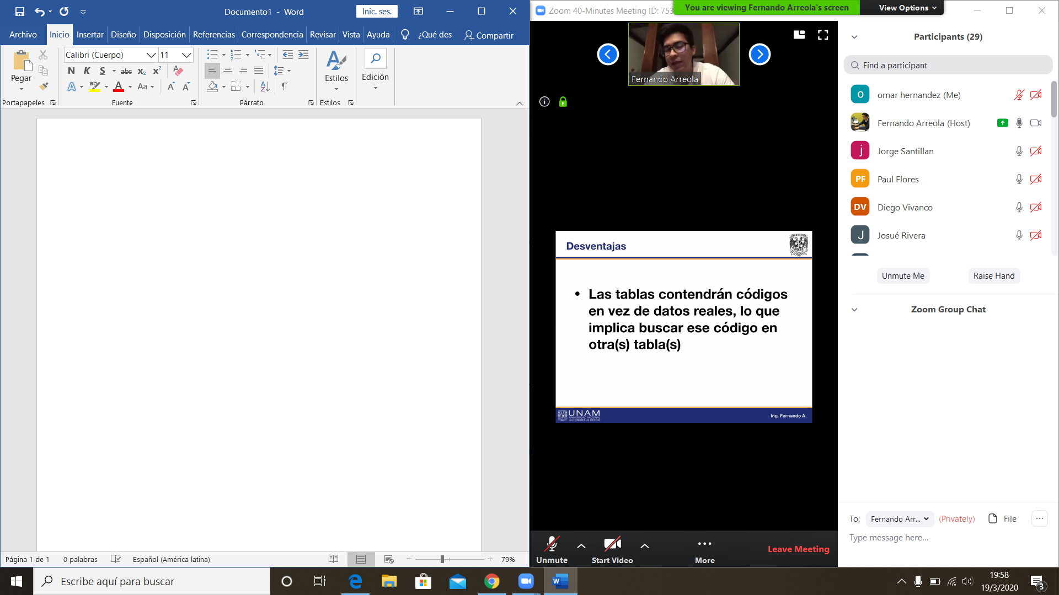

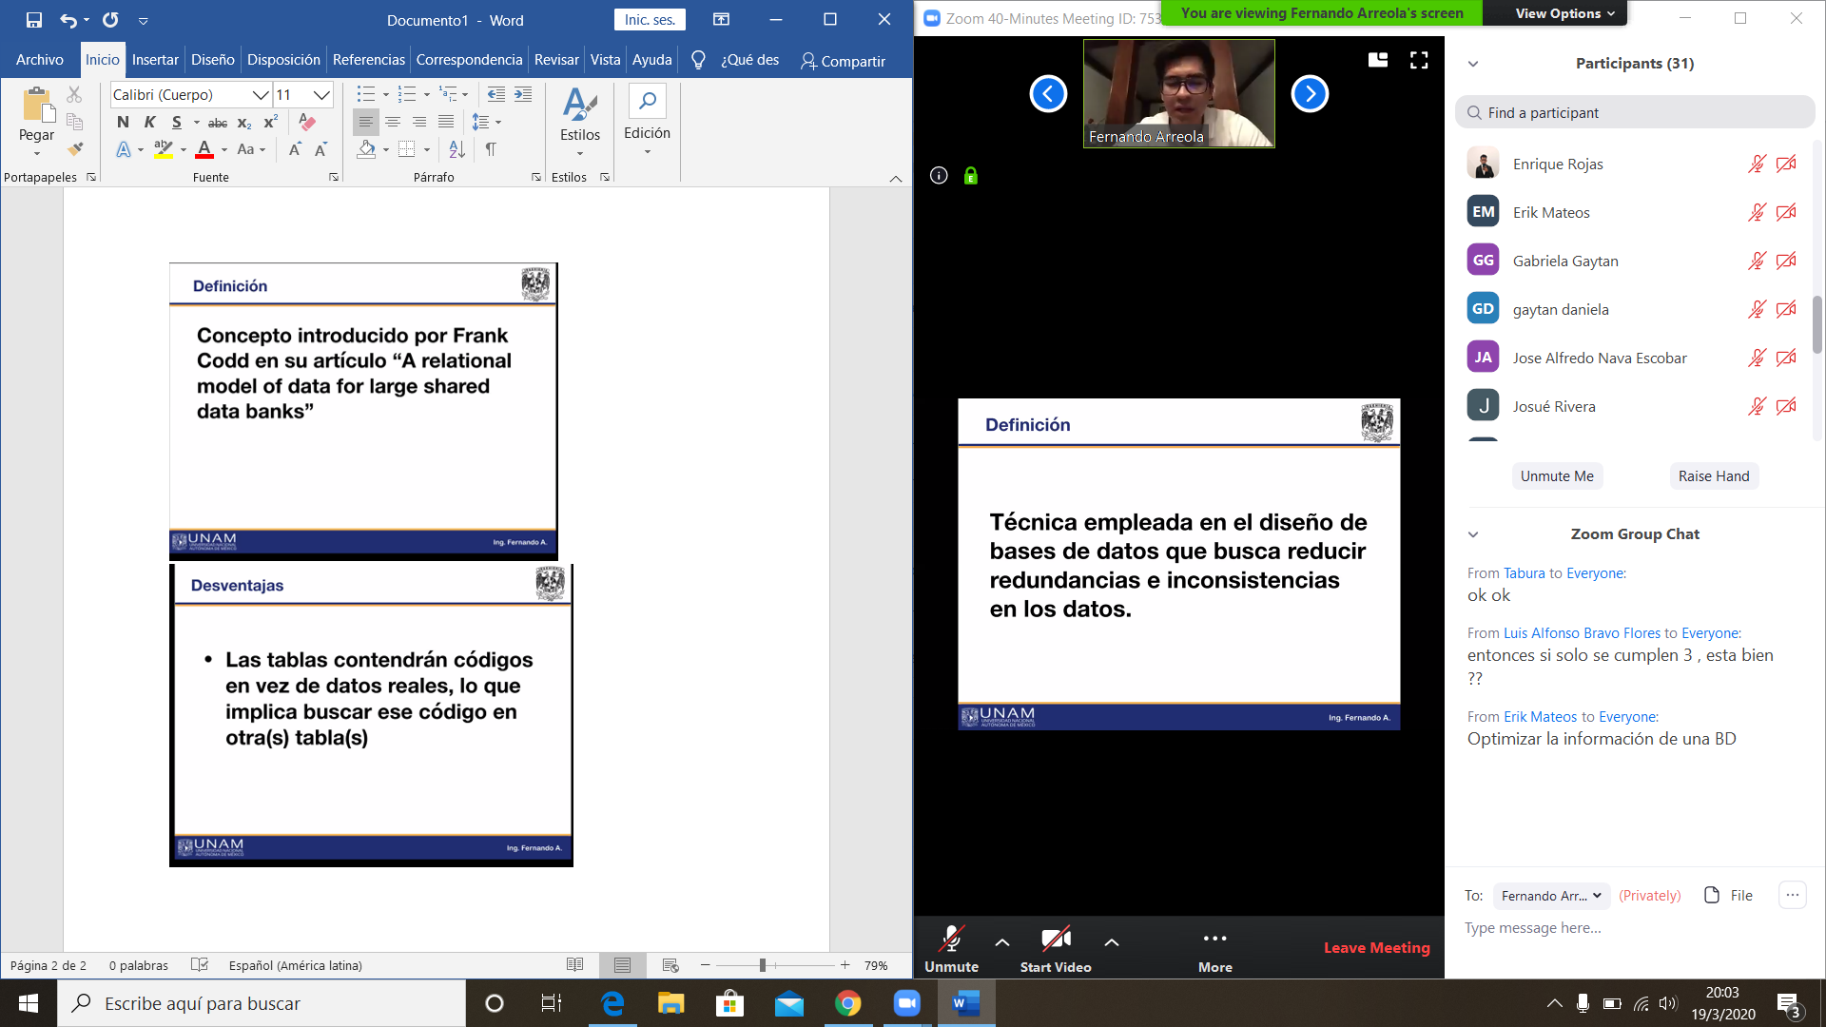

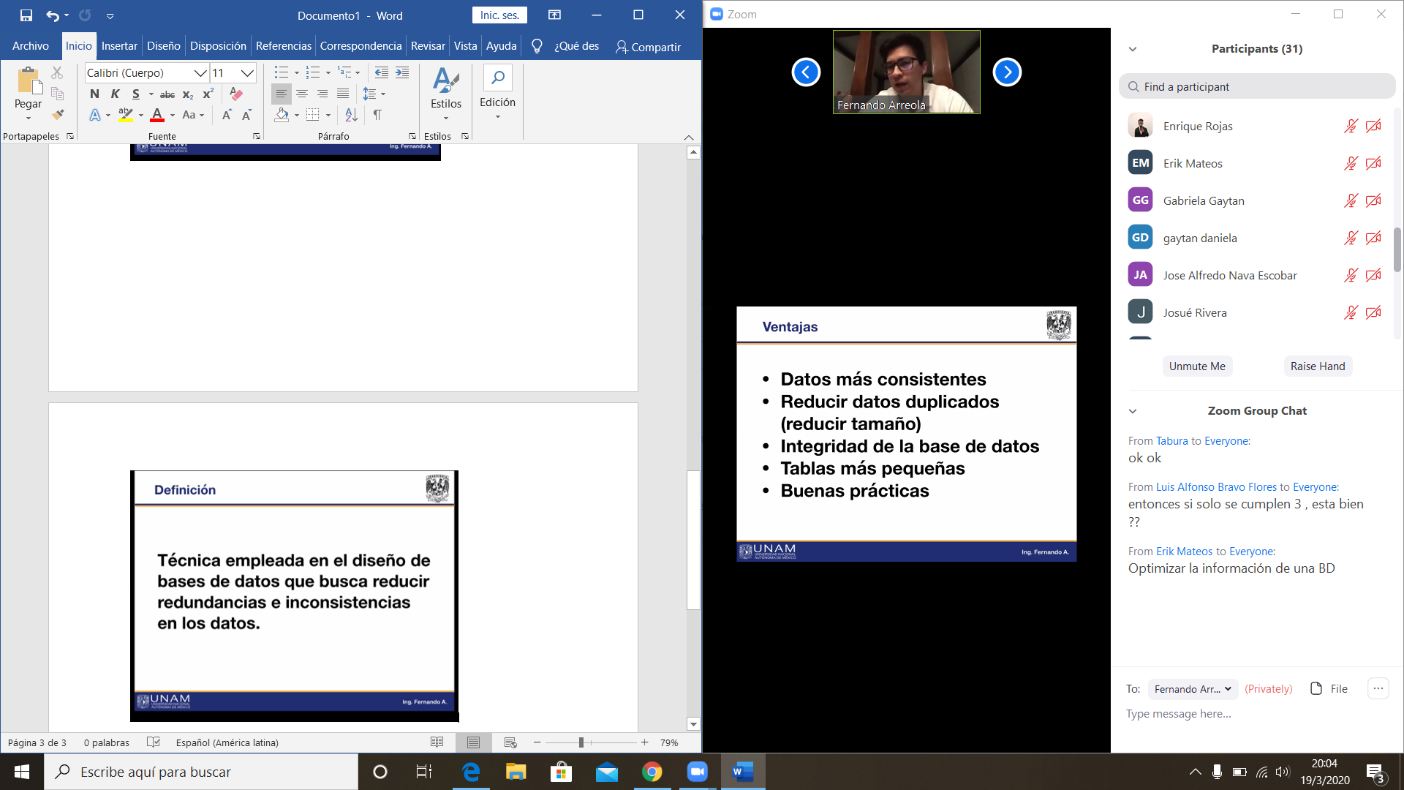

Base de datos ordenada

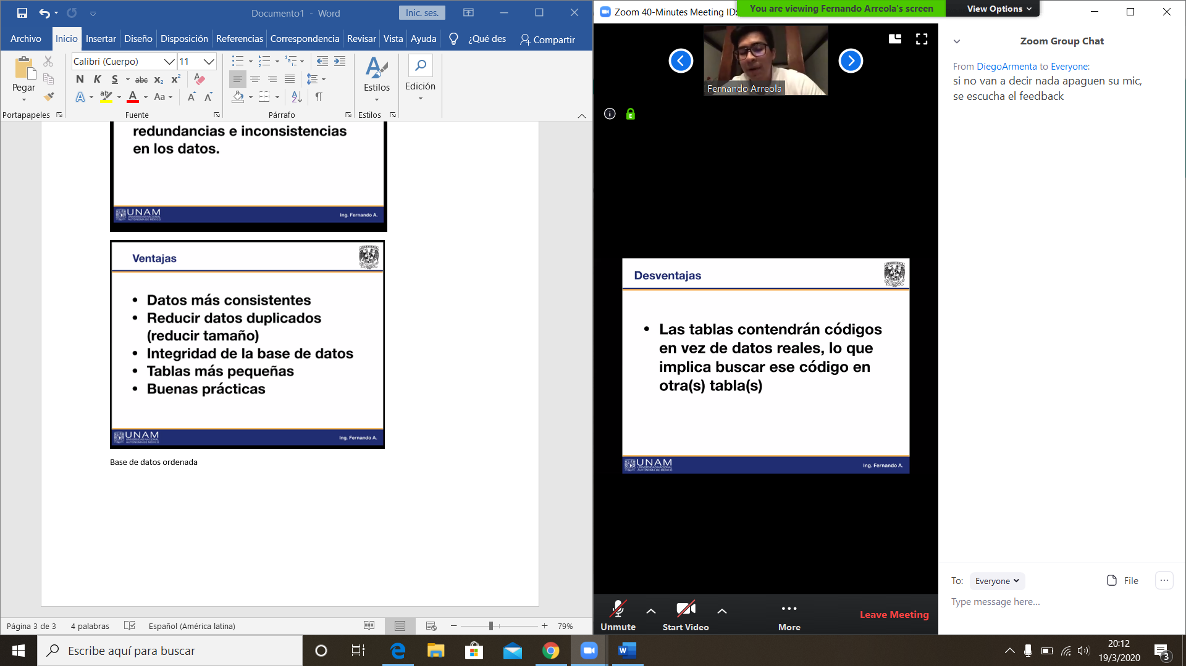

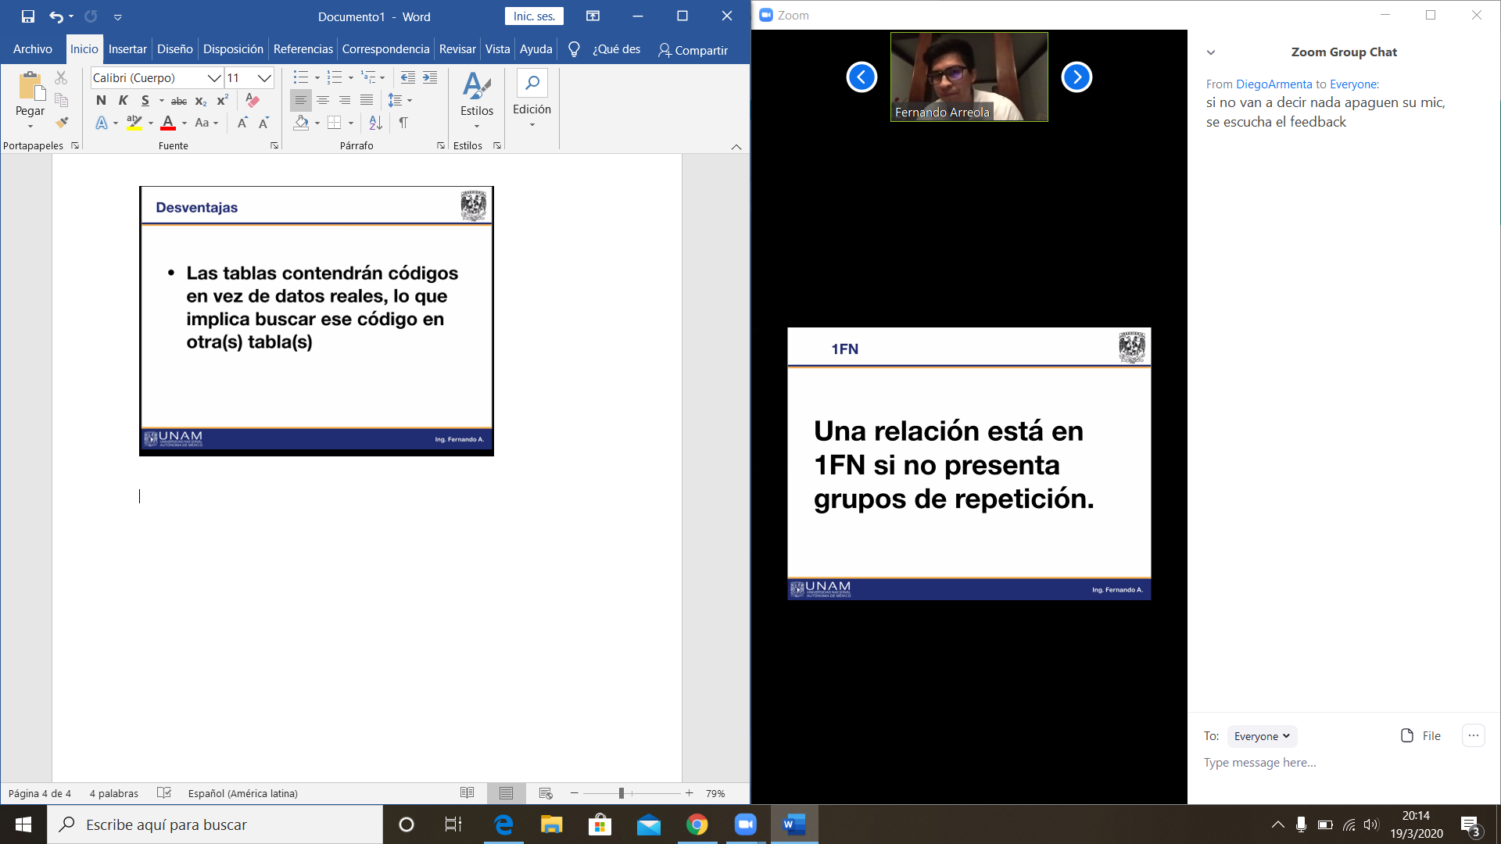

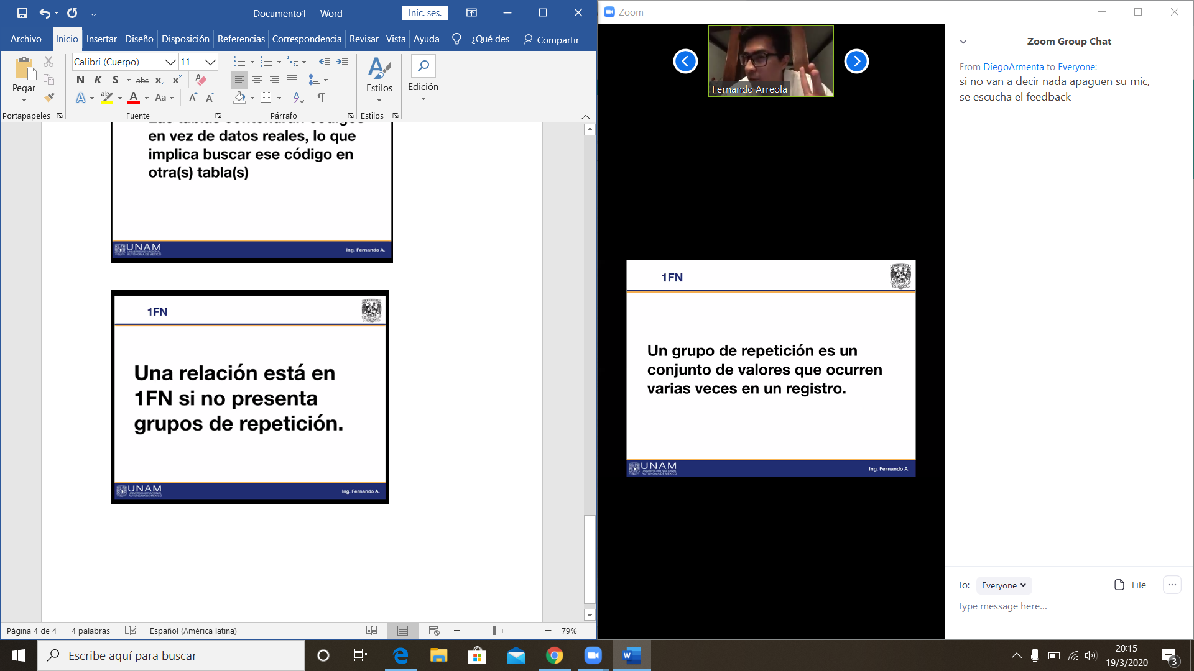

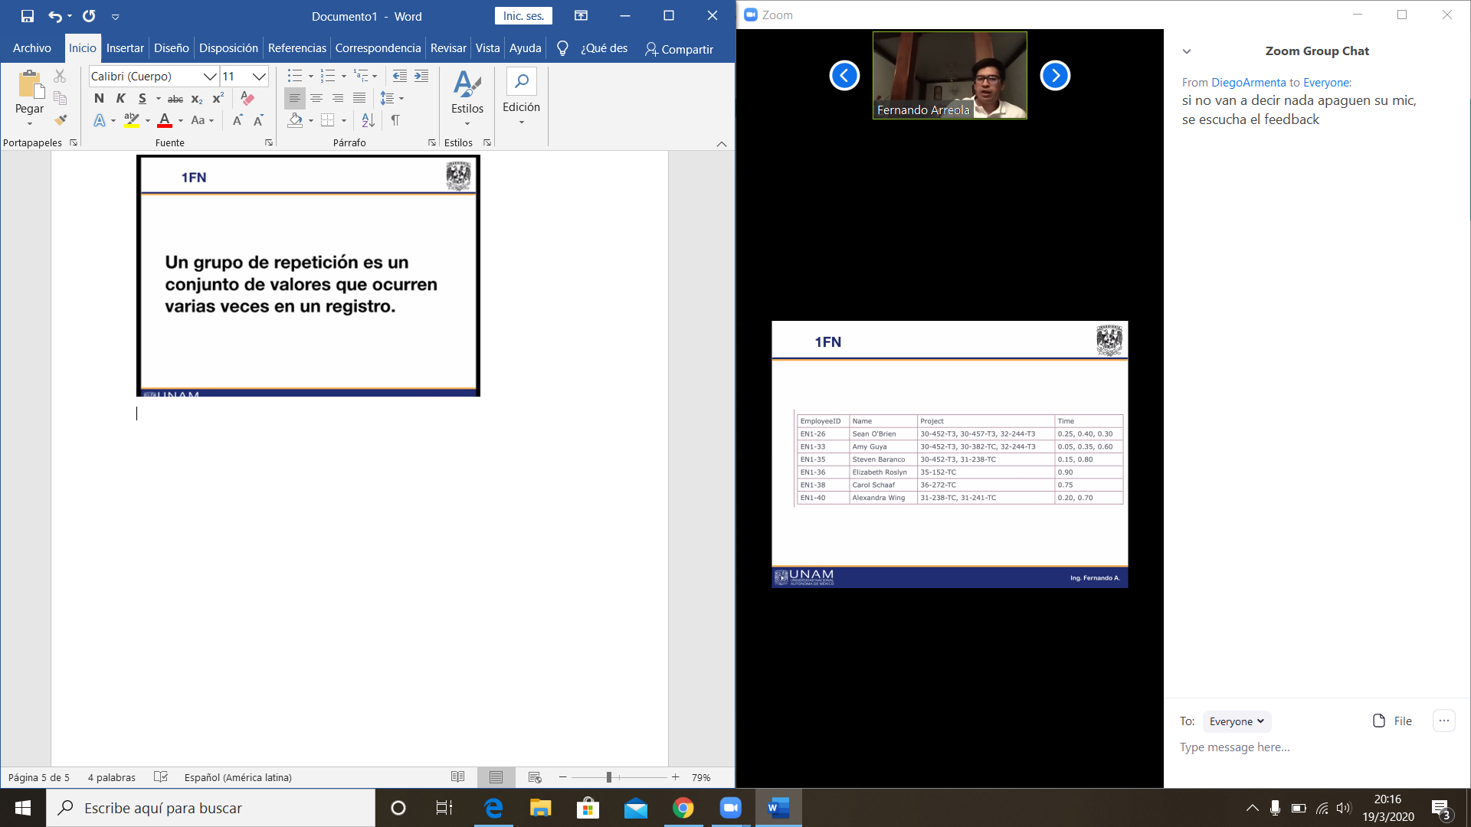

Varios valores en una tupla

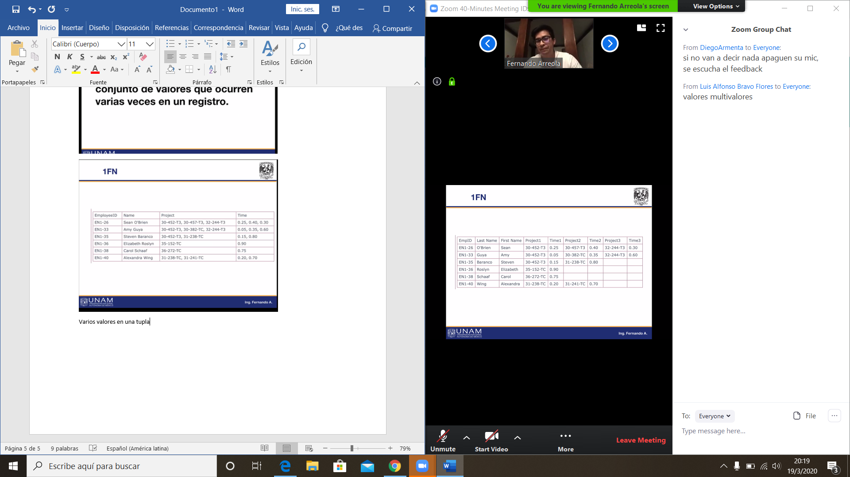

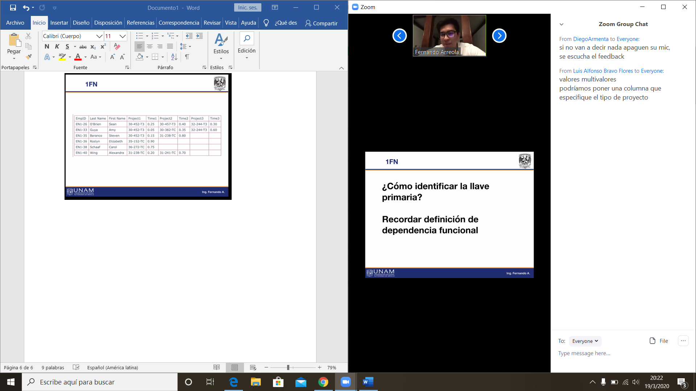

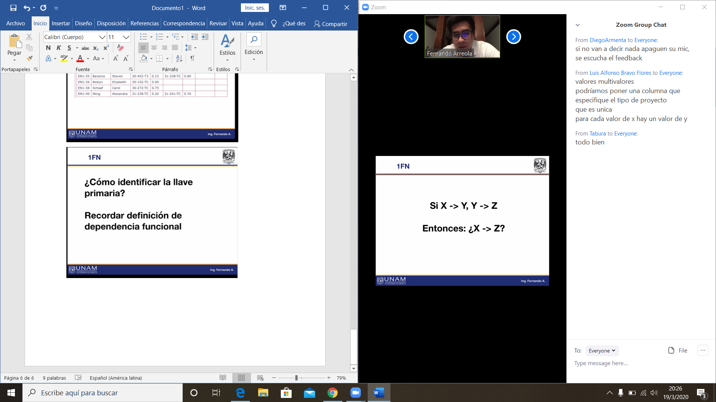

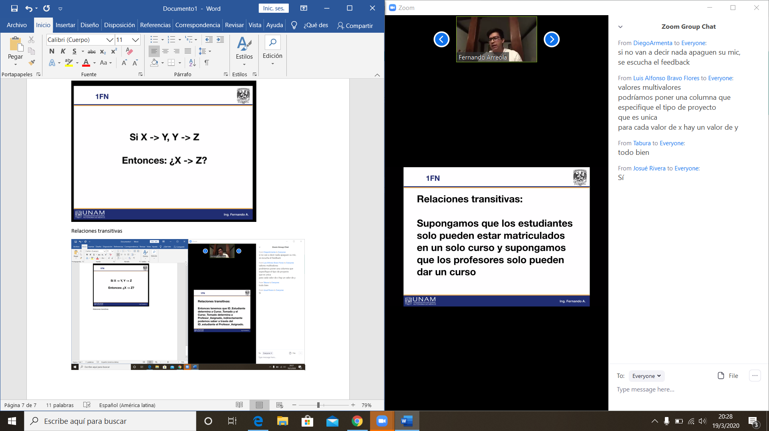

Relaciones transitivas

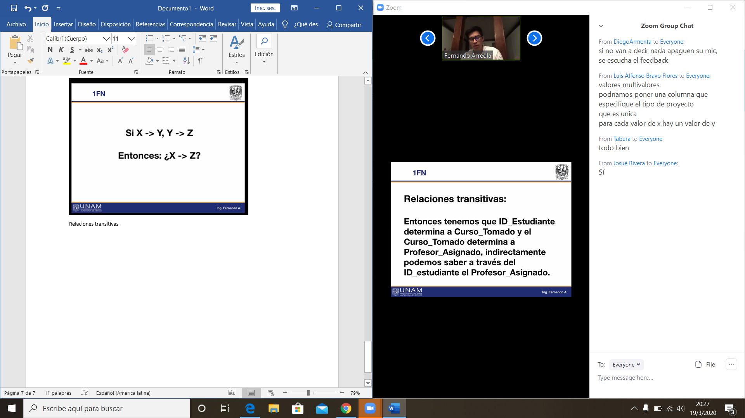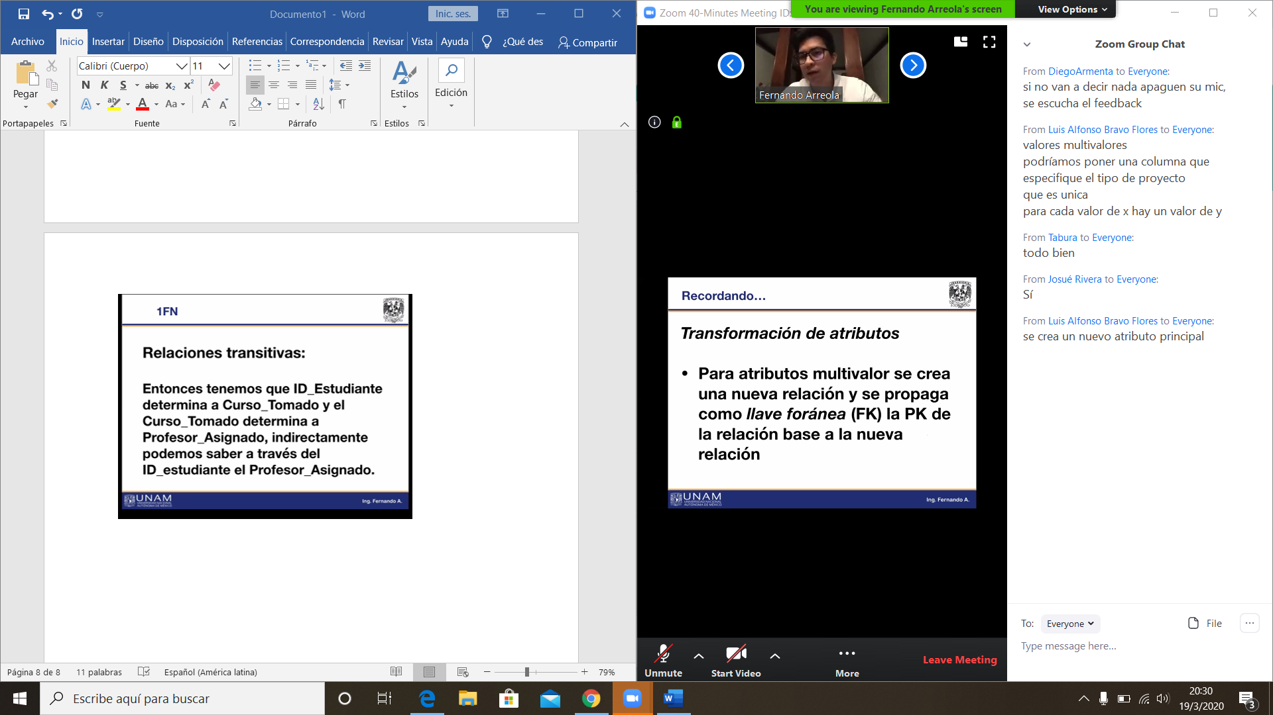

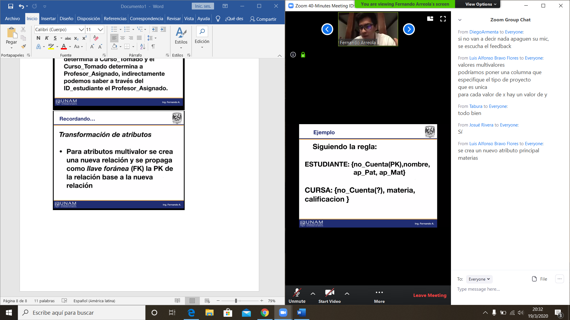

Cursa debe tener np_cuenta fk yluego pk

Podemos juntar nocuenta y materia

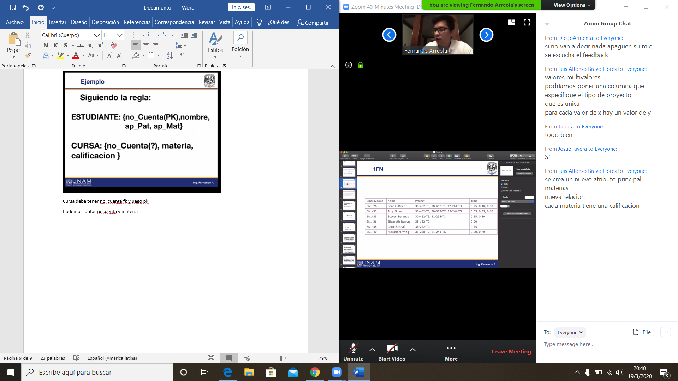

Empleado nombre

Empleadoprojectotime tarea

|  |  |  |
| --- | --- | --- |
| Employeeid | Project | time |
| EN126 | 30-452t3 | 0.25 |
| EN126 | 30-457-t3 | 0.40 |
| EN26 | 32-244-t3 | 0.30 |
| EN1-33 | 30-452t3 | 0.05 |
| EN1-33 | 30-382-TC | 0.35 |
| EN1-33 | 32-244-T3 | 0.60 |
| En1-35 | 30-452t3 | 0.15 |
| EN1-35 | 31-238-TC | 0.80 |
| EN1-36 | 35-152-TC | 0.90 |
| EN1-38 | 36-272-TC | 0.75 |
| EN1-40 | 31-238-TC | 0.20 |
| EN1-40 | 31-241-TC | 0.70 |